

**The University of Azad Jammu and Kashmir**

**Department of Software Engineering**

OEL

|  |  |
| --- | --- |
| **Course Title:** | Web Design & Development |
| **Course Code:** | SE-3208 |
| **Semester:** | 6th |
| **Session:** | 2022-2026 |

**Roll No:**

**2022-SE-22(Mashal kiani)**

**2022-SE-25(Alisha Pervaiz)**

**Bachelor Of Science In Software Engineering (2022-2026)**

**Department of Software Engineering**

# Weather Calculating web Application

## 1. Project Overview

The Weather Dashboard project is a web-based application that allows users to search for real-time weather information of any city using the OpenWeatherMap API. It displays data such as temperature, humidity, wind speed, and atmospheric pressure in a clean and interactive interface. The system fetches weather data dynamically based on user input and presents it in an attractive dashboard layout.

## 2. Objective

The main objective of this project is to provide users with quick and reliable weather updates for any location worldwide. It helps users make informed decisions based on weather conditions such as planning travel, outdoor events, or daily activities.

## 3. Tools and Technologies Used

• HTML5 – for webpage structure and layout.  
• CSS3 – for styling and responsive design.  
• JavaScript – for interactivity and API data handling.  
• PHP – for backend processing and API integration.  
• OpenWeatherMap API – for fetching live weather data.  
• Bootstrap – for responsive UI components.

## 4. System Design and Working

The Weather Dashboard consists of a front-end interface built with HTML, CSS, and JavaScript, and a backend built with PHP. The front-end provides a search box where users can enter the name of a city. When the user clicks on the 'Search' button, the JavaScript code sends a request to the PHP backend (weather.php) along with the city name.

The PHP file then communicates with the OpenWeatherMap API using the provided API key, retrieves weather details in JSON format, and sends them back to the front-end. The JavaScript code then extracts and displays the information such as temperature, humidity, wind speed, and pressure in a user-friendly layout.

## 5. Folder Structure

weather-dashboard/  
│  
├── index.html → Main front-end interface  
├── weather.php → Backend PHP script handling API requests  
└── config.php → Stores API key and configuration settings

## 6. Features

• Real-time weather data retrieval from OpenWeatherMap API.  
• Displays temperature, humidity, wind speed, and pressure.  
• Dynamic and interactive user interface.  
• Responsive design for different screen sizes.  
• Error handling for invalid city names or missing input.  
• Visual icons representing different weather conditions.

## 7. Implementation Details

The weather dashboard’s implementation follows a clear separation of concerns:  
- The front-end (index.html) handles user input and display.  
- The backend (weather.php) manages data requests and API communication.  
- The configuration file (api-config.php) securely stores the API key, which is not exposed to the public.  
When a city name is entered, the system dynamically fetches and updates weather data without reloading the page.

## 8. Output and Results

Once a user enters a valid city name, the dashboard displays the following results:  
• City Name and Country  
• Current Temperature in Celsius  
• Feels Like Temperature  
• Humidity Level  
• Wind Speed  
• Atmospheric Pressure  
• Weather Condition with an appropriate icon

## **Screenshot Placeholder:**

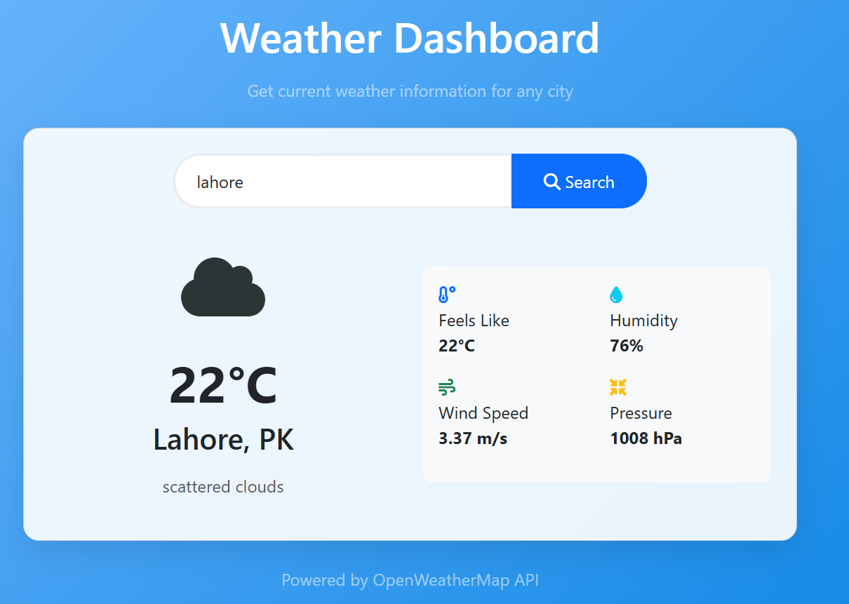

## 9. Conclusion

The Weather Dashboard project demonstrates the integration of client-side and server-side technologies to create a real-time weather information system. It provides users with accurate and instant weather updates in an intuitive interface. This project showcases practical use of APIs, asynchronous data handling, and responsive web design.